Model no |  | YS1008-K-G-C13-U |  | 1.0U 8*C13 outlets with anti-off locking, with switch,overload protection,USB charge
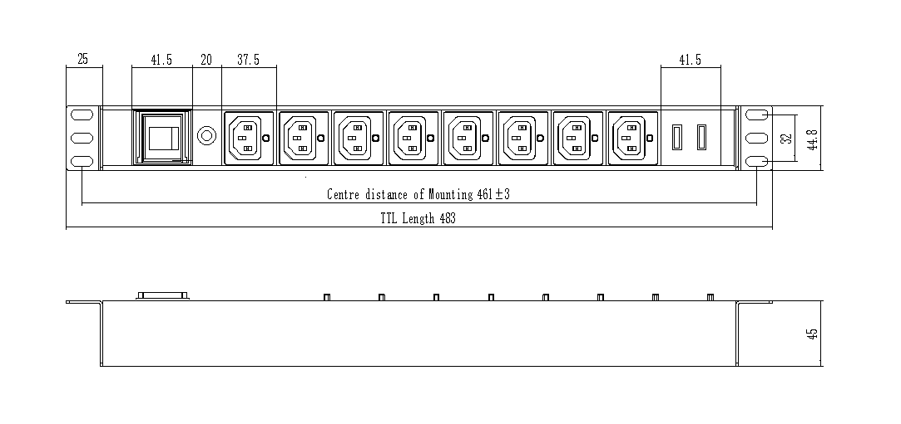
10 | Spare parts |  | Mounting screw and nut 4sets, Installation Mannual |  | 11 | Rated current |  | 13A
9 | Function |  | Overload protection，switch，5V2.1AUSB |  | 12 | Rated voltage |  | 250V
8 | Plug |  | BS plug |  | Customer  ATTN | Ismet C Soy |  | Customer  approval
7 | Socket |  | 8* C13 with anti-off locking
6 | Connection box |  | none |  | Customer | Chronos Network Telecom.Consulting
5 | Cable spec |  | 3*1.5mm2*2metre
4 | Installation |  | 25+25mm mounting hook 180° horizontal
3 | Mounting distance |  | 461±3mm
2 | Product size |  | 483*44.8*45mm |  | Date | Engineer | Scale
1 | Housing Material |  | Black 1.5U Aluminium, 45mm high |  | 2021.4.9 | Lee | 1.1

